TI 23 – 13 Technology Example – CoViz 4D subsurface reservoir visualisation and integration software
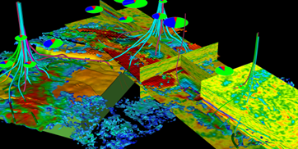

CoViz 4D Software: Dynamic Visual Analytics and Data Integration

for Better, Faster, and More Confident Decisions
COVIZ® 4D excels in delivering quantitative co-visualization of 2D, 3D, and 4D data in a variety of industries and application areas.
Our advanced, flexible visualization environment helps you gain a deeper understanding of your surface and subsurface data, regardless of the application—energy, environment, government, or academia. The ability to rapidly integrate, visualize, and analyze diverse spatial and temporal datasets improves insight and optimizes subsequent decision making.
One major usage area for CoViz 4D is subsurface reservoir management, in both onshore and offshore fields. Understanding the changing response of a hydrocarbon reservoir over time is critical for optimizing development decisions and subsequent production. CoViz 4D makes it possible for multi-disciplinary asset teams to simultaneously view and interrogate all available data from seismic to simulation, regardless of the original data source. The understanding gained through data fusion is powerful in 3D and increases enormously when all 4D temporal data can also be integrated. The unique temporal functionality in CoViz 4D allows users to visualize and understand how development decisions affect the reservoir throughout the history of a field.
Alongside reservoir management, CoViz 4D has optional modules for seismic forward modeling (Sim2Seis), 4D Geomechanics, and sophisticated well planning.

Vendors web site link for further information:
Link: Analysis Software for Reservoir Simulation & Modeling | CoViz 4D (dgi.com)

